Lab: Monitor Multiple VMs with Prometheus, Node Exporter & Grafana
In this lab, you’ll provision multiple virtual machines, install Node Exporter to expose system metrics, configure Prometheus to scrape those metrics, and build a Grafana dashboard to visualize your fleet’s health.

Prerequisites
- Prometheus and Grafana are installed and running.
- Ansible control nodes are configured (for installing Node Exporter on VMs).
- Terraform is installed and configured (to create the VMs).
- Network access between Prometheus/Grafana and the VMs (Node Exporter defaults to port 9100).

Learning Objectives
- Provision multiple VMs with Terraform.
- Install and configure Node Exporter on each VM using Ansible.
- Add the VMs as scrape targets in Prometheus and verify metrics ingestion.
- Connect Grafana to Prometheus and build a multi-host dashboard (CPU, memory, disk, network).
By the end, you’ll have an end-to-end monitoring setup that turns raw VM metrics into clear, actionable Grafana visuals.

Steps to follow -

To complete the lab, we will follow the following steps -

- Provision virtual machines using terraform
- Install node exporter on all virtual machines using ansible
- Configure prometheus.yml configuration file to add the above virtual machine to collect metrics.

Note - Execute all these steps from a virtual machine that has ansible and terraform installed and configured.

Clone the code repository from here - Lab - Monitor VMs code repository

Note - This code repository has some extra files that will be used in the future labs

Provision virtual machines using terraform

In the code repository cloned above, there is a folder with name provision_vm_terraform, this directory has two further directories - Azure (Modules to create VMs) and local_solution to create infrastructures.

Switch to the local_solution directory and update the value of the prefix in the local.tf file

prefix = "devops2-week8-prometheus-lab"

This variable is used in creating all other resources like resource group, nsg, etc.

Next, execute the terraform flow.

terraform init

terraform plan

terraform apply --auto-approve

The apply command will provision two virtual machines. There public ip address you can get from terraform output command.

terraform output public_ip

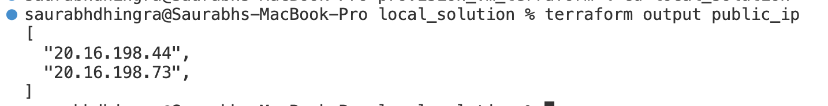

To get SSH private key to connect to these VMs via ssh run the following command.

terraform output tls_private_key >> key.pem

Copy this key.pem in the other folder (install_prometheus_agent) folder.

mv key.pem ../../install_prometheus_agent

Update the permission of the file to 400.

cd ../../install_prometheus_agent

chmod 400 key.pem

Update the inventory.ini with the IP address of the virtual machines provisioned above.

[prometheus_agents]
vm1 ansible_host=20.16.198.44
vm2 ansible_host=20.16.198.73
[all:vars]
ansible_user=azureuser
ansible_ssh_private_key_file=./key.pem
ansible_python_interpreter=/usr/bin/python3.12

Next, verify the ssh connection with both the virtual machines.

ssh -i ./key.pem azureuser@<public_ip_address>

We are ready to install the node exporter agent on both the virtual machines.

Install node exporter on all virtual machines using ansible

Let us first verify that both machines are accessible via ansible. Execute the below commands -

ansible all -m ping

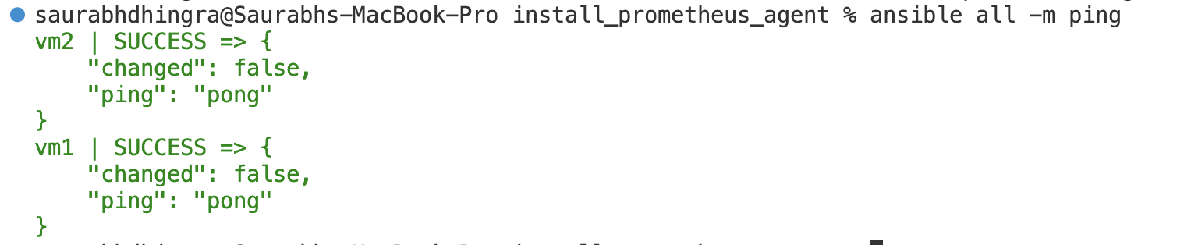
Next, execute the ansible playbook to install node exporter agent.

ansible-playbook install_agent.yml

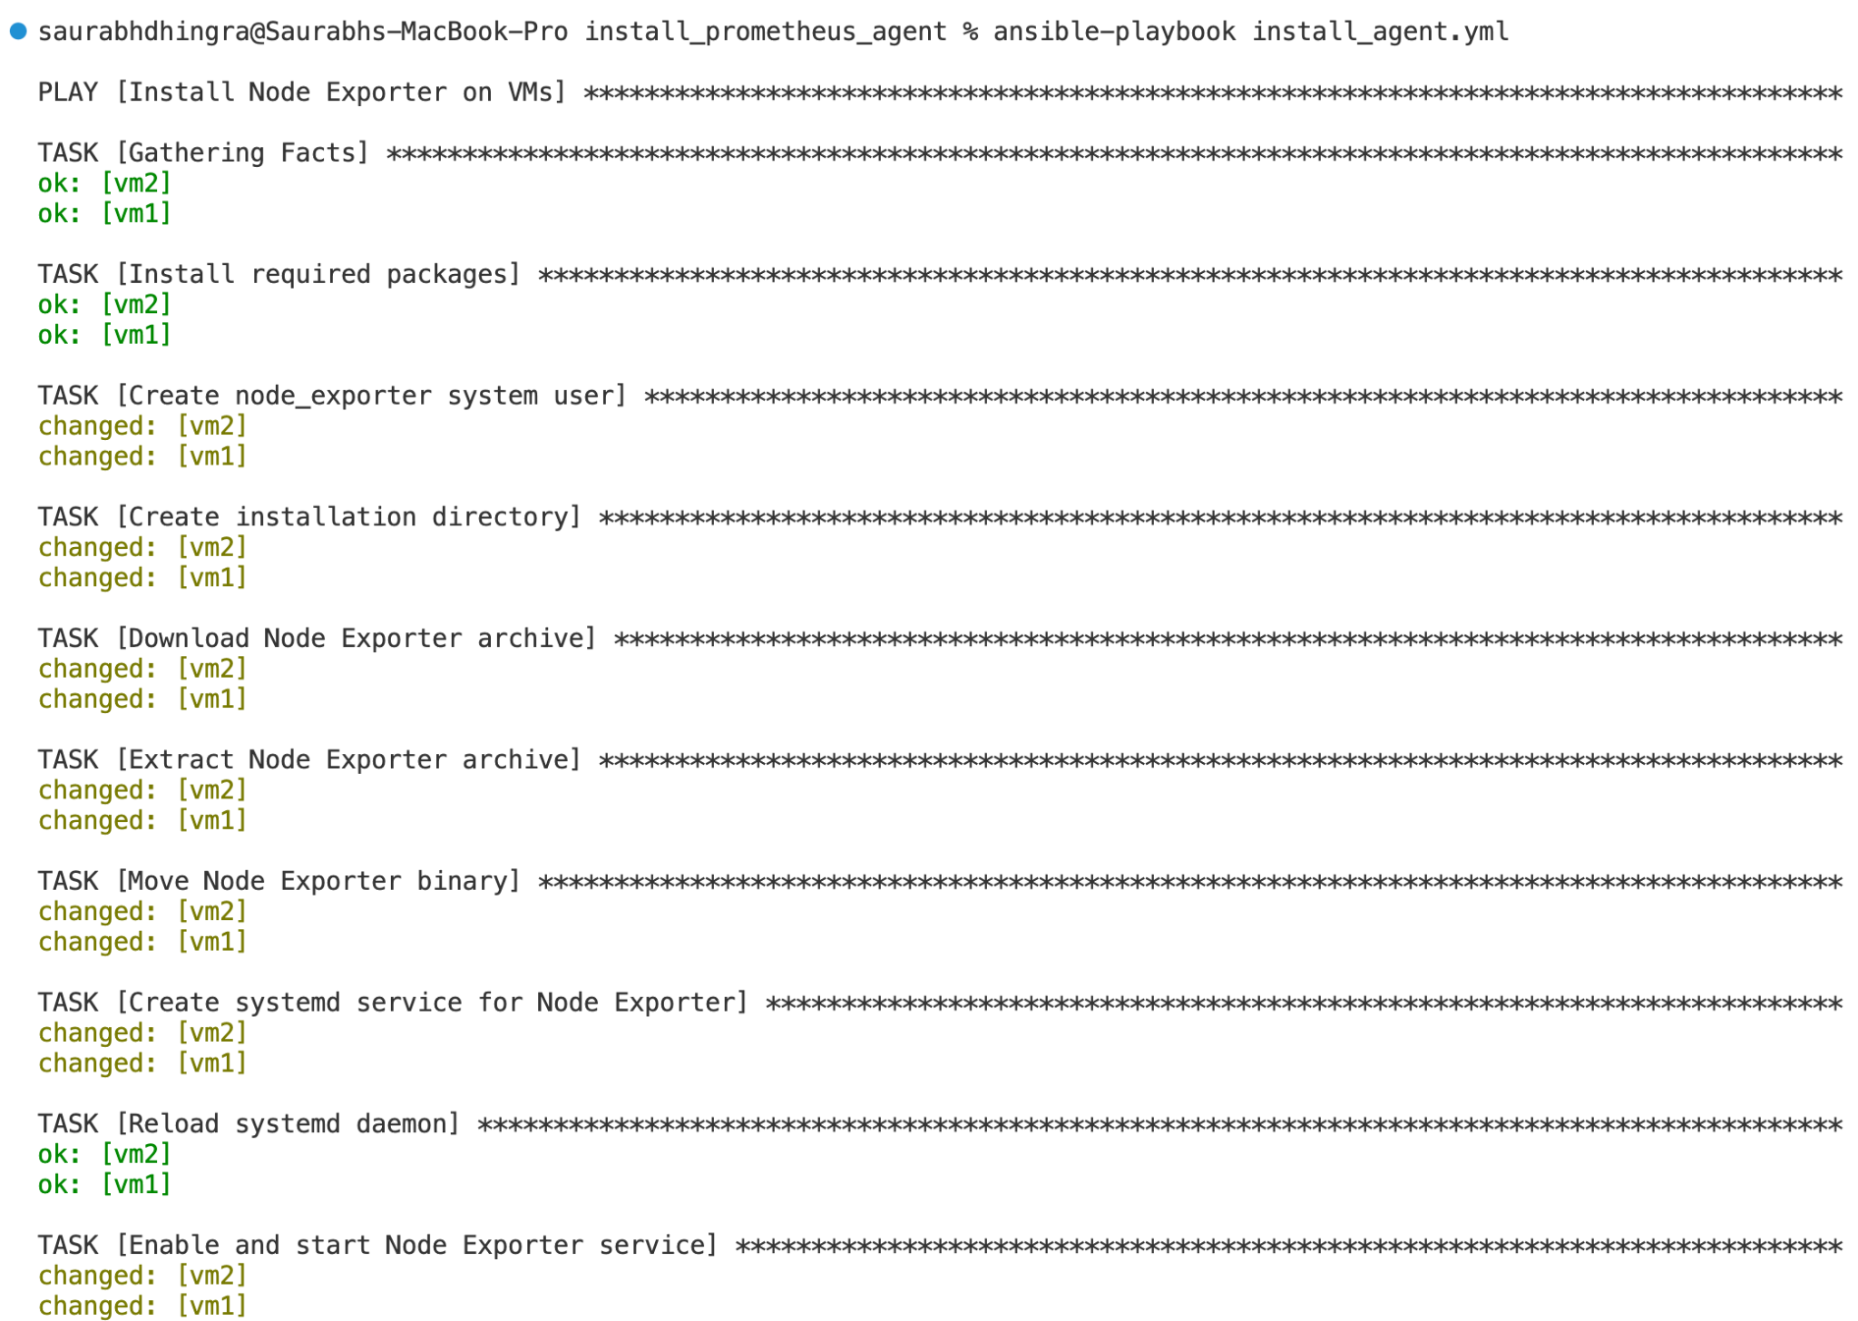

Configure prometheus.yml configuration file to add the above virtual machine to collect metrics.

NOTE - The next two steps (to update prometheus.yml and restart the server) will be performed on the Virtual machine where you installed Prometheus and Grafana

Next, connect to the virtual machine via ssh that has prometheus and grafana installed.

ssh -i username@<IP address of Prometheus VM>

Next, navigate to the folder where you had copied the code to set up Prometheus and Grafana.

Update the prometheus.yml file with the following code.

global:
scrape_interval: 15s
scrape_configs:
- job_name: 'prometheus'
static_configs:
- targets: ['localhost:9090']
- job_name: 'node_exporter'
static_configs:
- targets: ['20.16.198.44:9100', '20.16.198.73:9100']

Note - Make sure to update the IP address in the last field to the IP address of the VMs created above.

Also, make sure to keep the port 9100 enabled. If you are using the terraform scripts from the code repo shared above. This step is already done

The Next step is to restart the Prometheus server. Execute the following command

docker compose stop prometheus

docker compose start prometheus

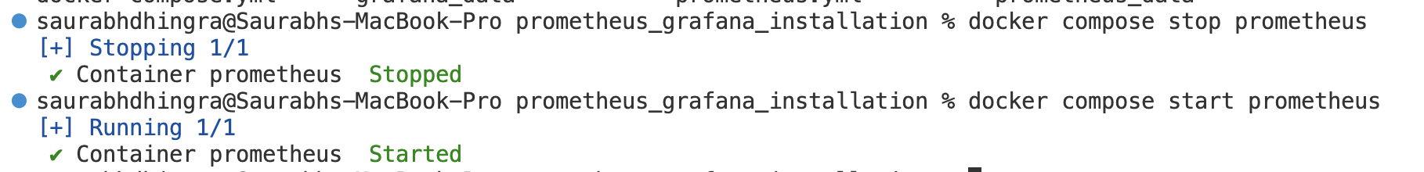

Verify the metrics are collected by the Prometheus server.

Navigate to the prometheus server

http://<prometheus_server_ip_address>:9090

In the query field copy paste the following query.

node_cpu_seconds_total

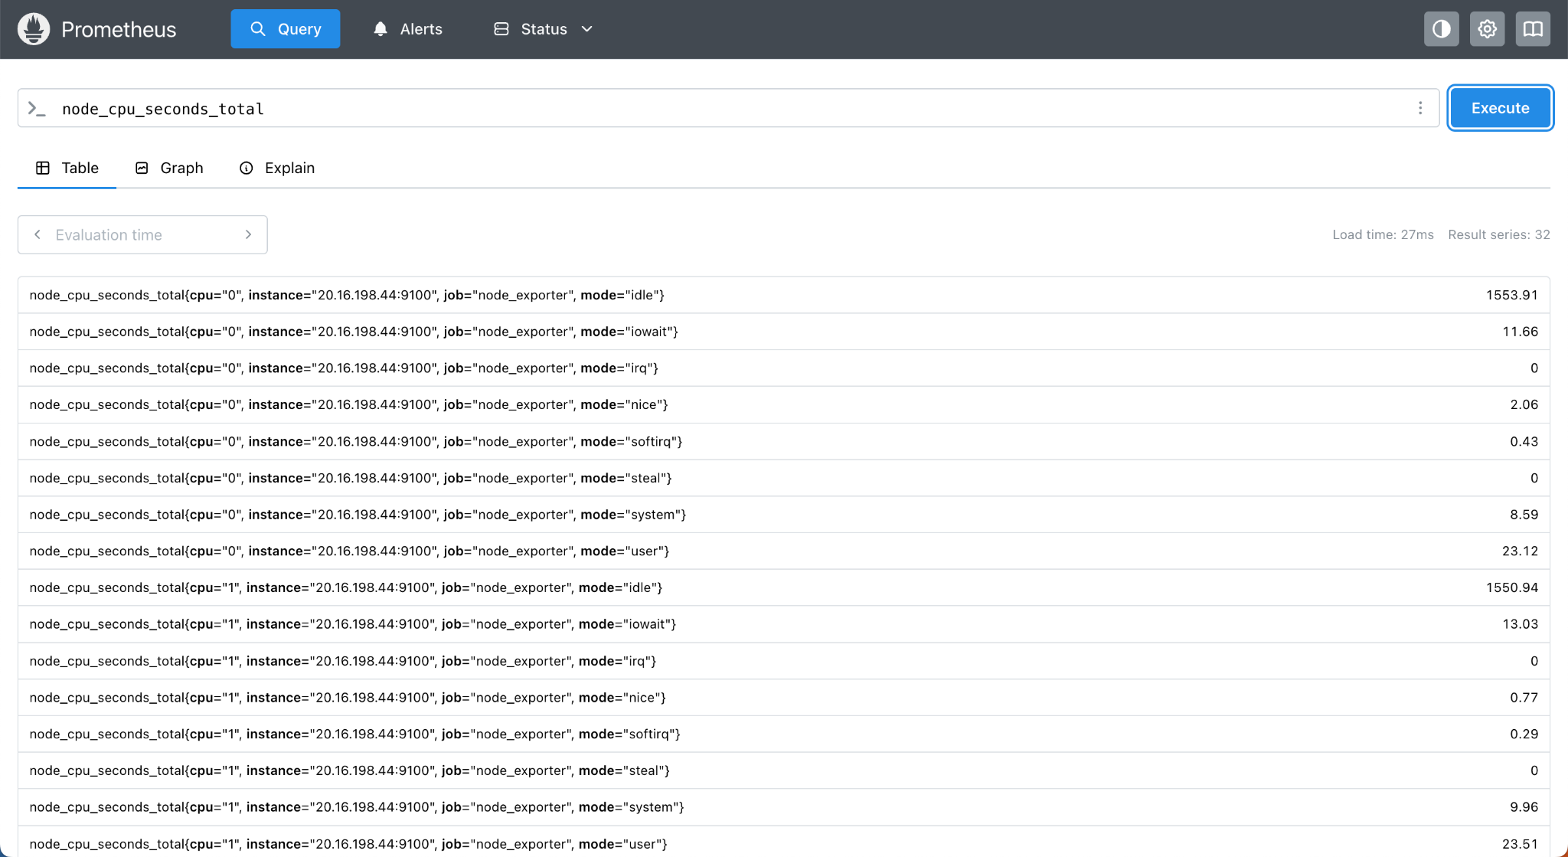

You can notice the data coming from the virtual machines configured in the previous steps.

This means the Prometheus server collects the data from both the virtual machines.

Build a dashboard in Grafana
Note - These steps you can perform from your own laptop (or local system)

In this lab, we will use a template to create standard dashboards that present useful information from the node exporter like agent.

One of the commonly used template is this - Node Exporter Full Template

Download the latest version of the template. The current version while creating this lab is 40

Scroll down a bit and you will see this section on the link shared above.
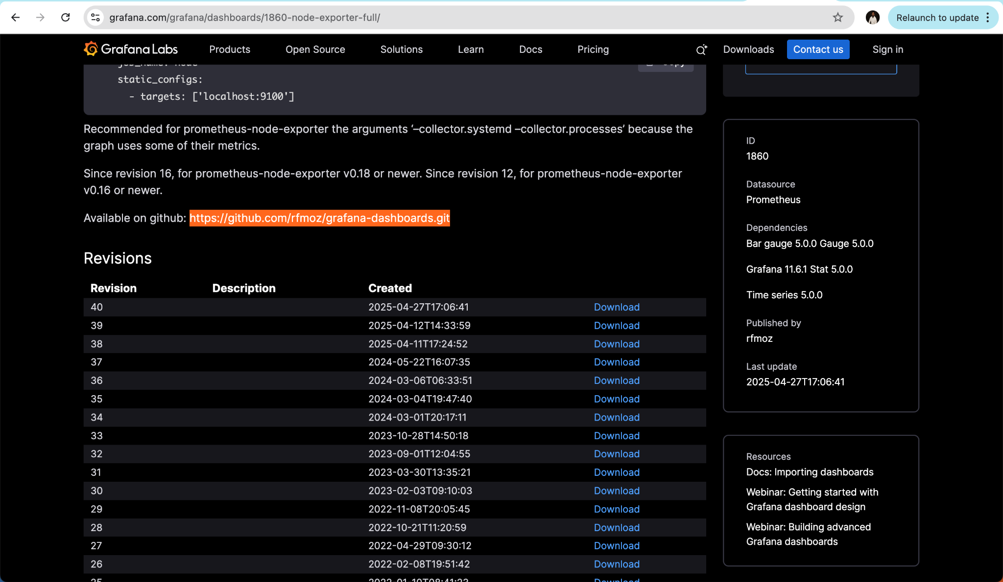

Download the template.

Next, navigate to the Grafana homepage, login with the credentials.

Navigate to the Dashboard section

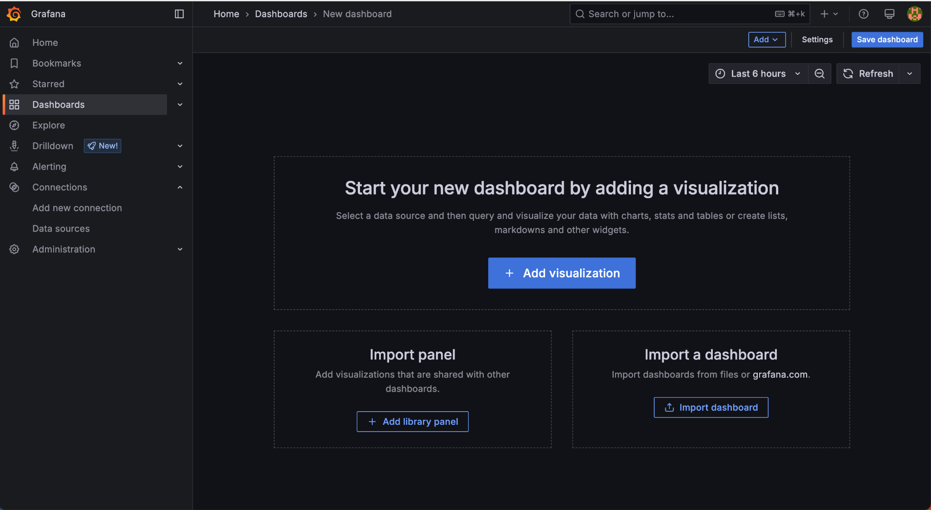

Next, save the dashboard with some name say “Monitoring VMs”. Click on Save Dashboard on the top right corner.

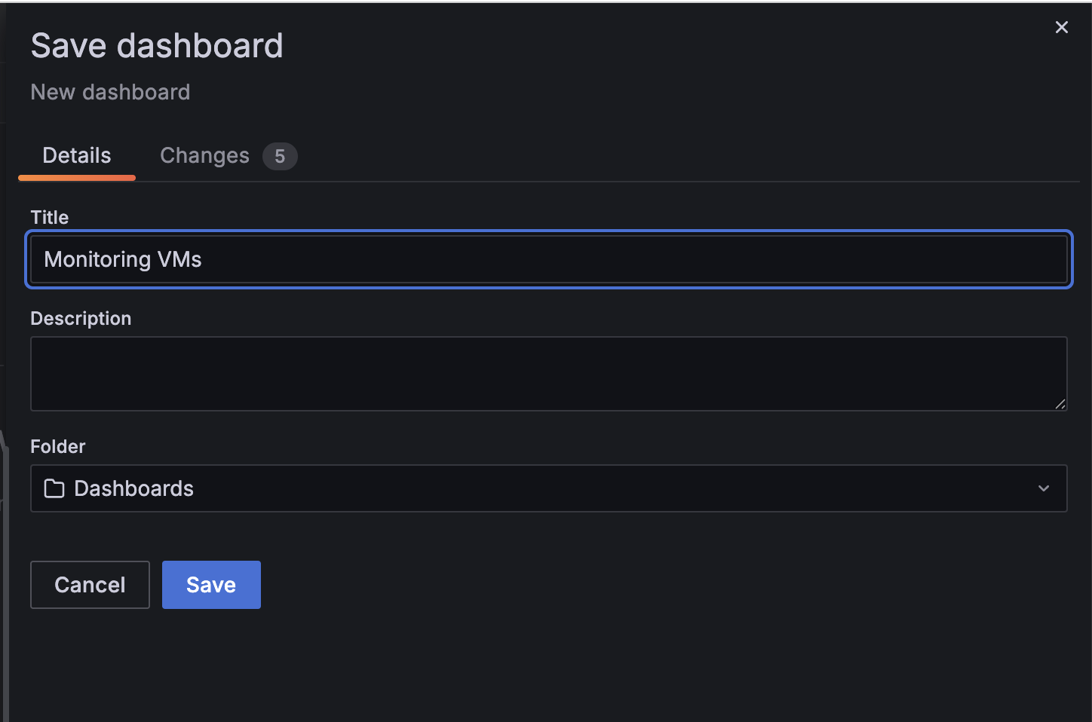

Next, select the third option on the screen. Import a dashboard.

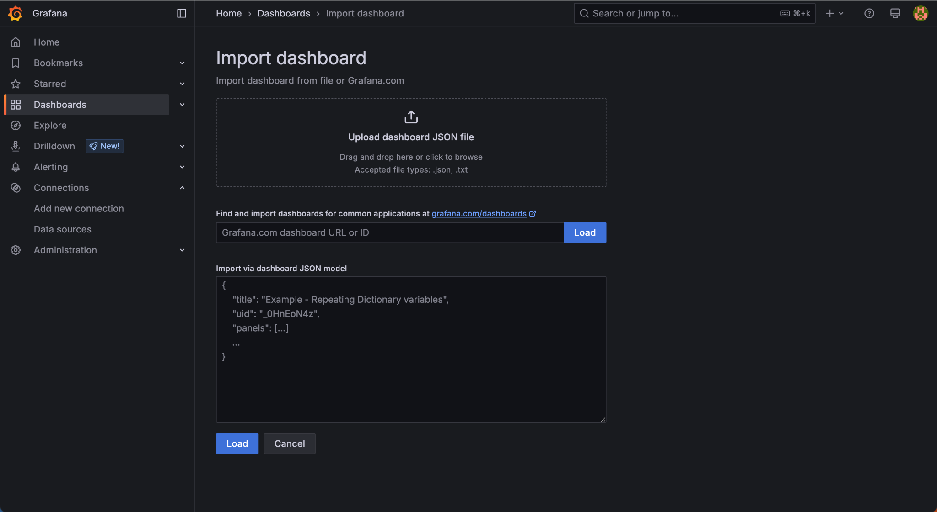

Upload the json you downloaded from the template page.

Update the source in the last column and click Import.

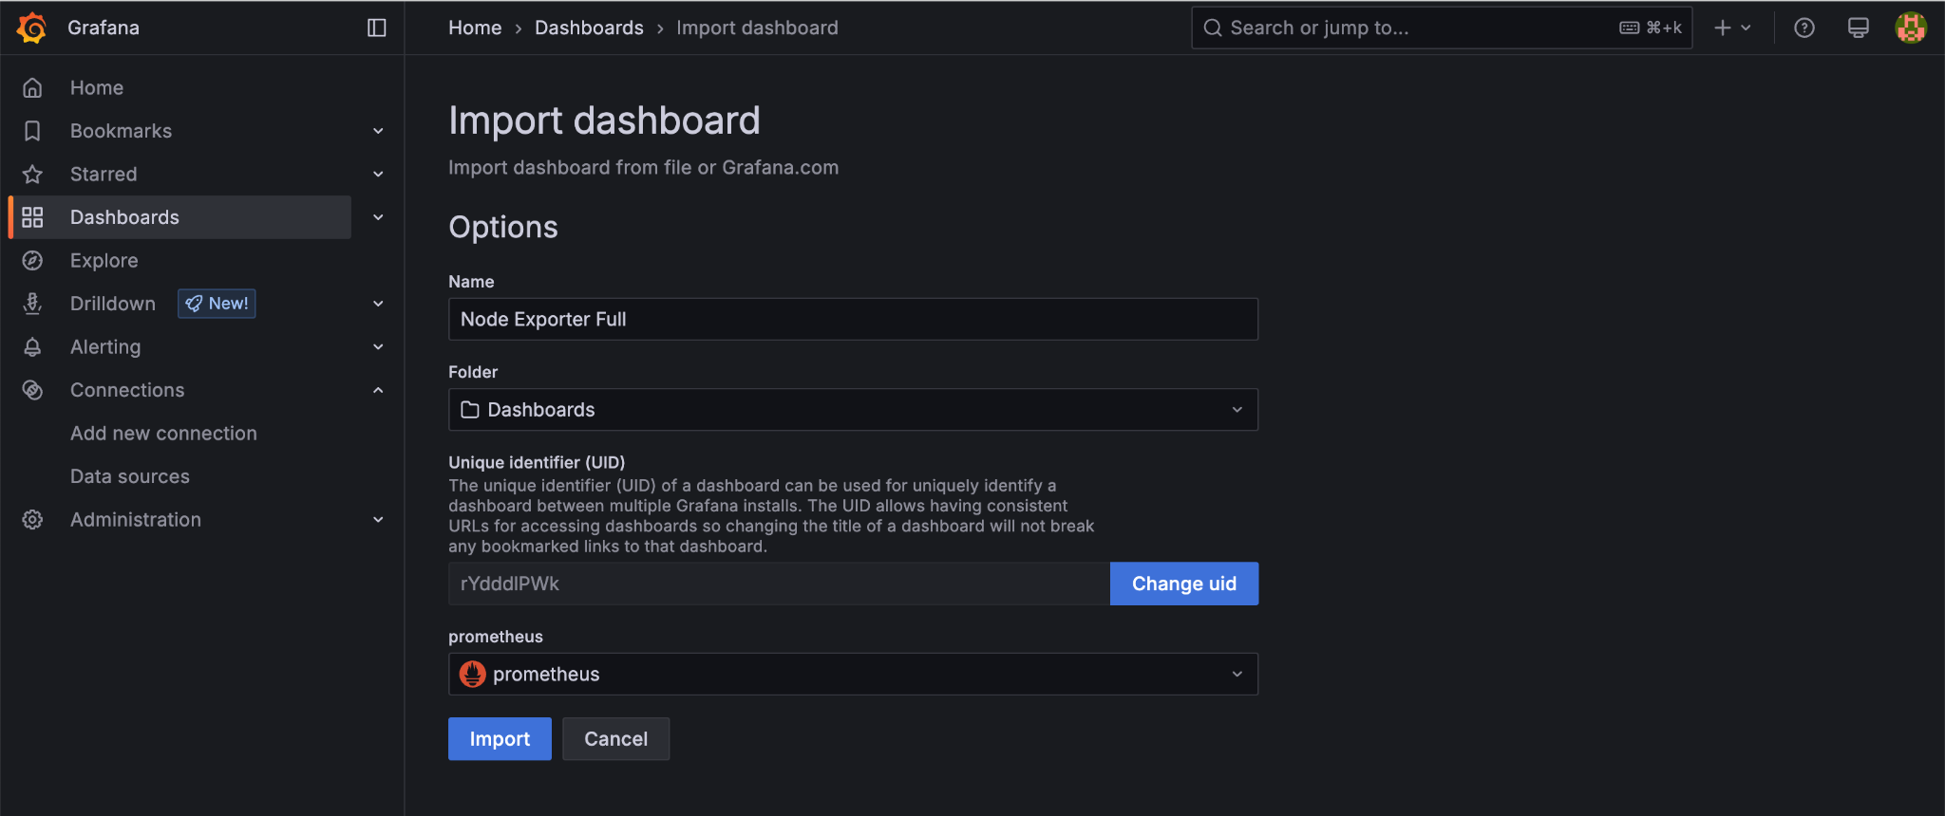

In a few seconds you will see a well informative dashboard like below.

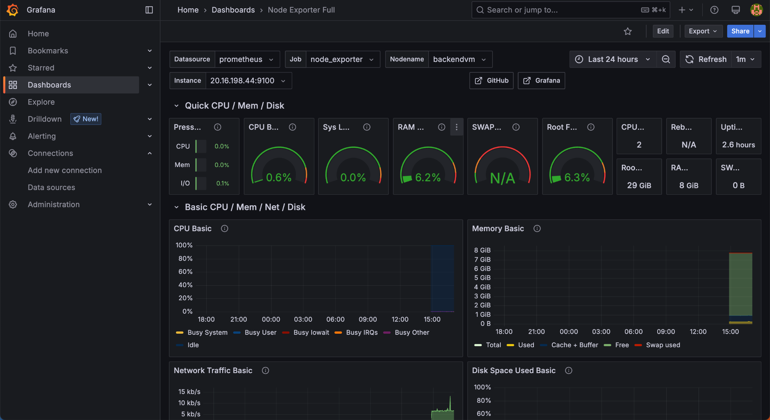

This Dashboard presents a lot of information like CPU utilization, Sys Load, RAM Utilisation, Network Usage, Disk Space Usage, etc.

Take some time to explore the Dashboard.

You can also get the data from a single VM or multiple VMs. Change the source from the highlight dropdown below.

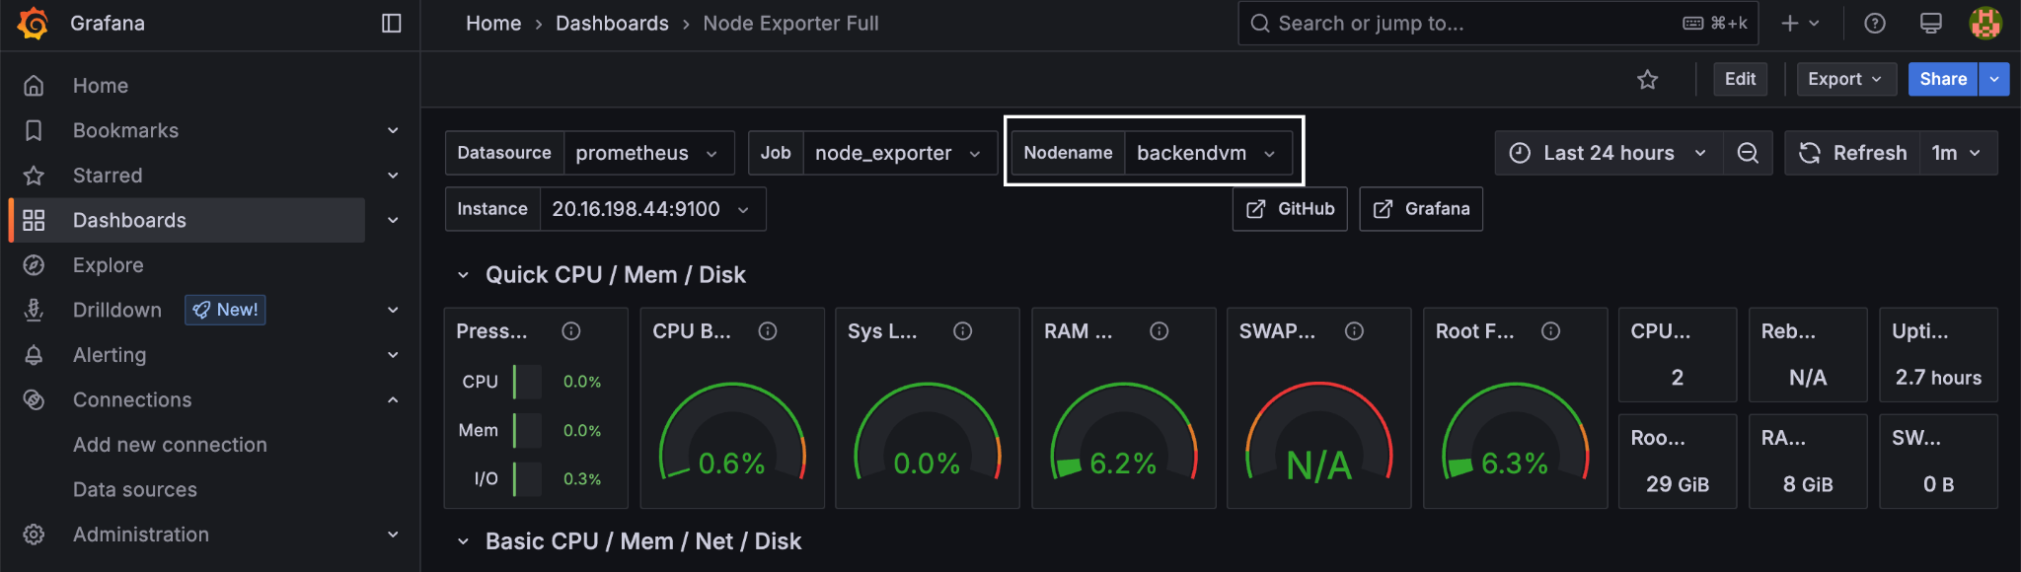

Congratulations, you have successfully completed this lab, where we build a dashboard from scratch using the data collected from the virtual machines using the node exporter.

